DataMining_Module

Permission denied: ‘/usr/bin/dumpcap’

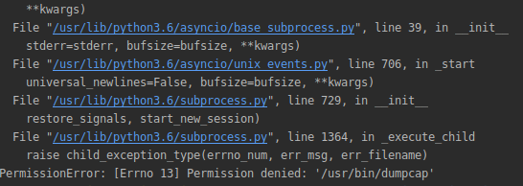
possible solution

DataMining_Moduloe

Permission not permite /sniff of scapy

possible solution

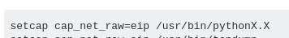

where pythonX.X is the version 3.6

